ASSET MANAGEMENT PORTAL
1.Introduction
The Asset Management Portal is developed to efficiently manage and track organizational assets. The system maintains asset records, monitors asset status, manages employee allocation, and automates processes such as warranty tracking and asset condition updates
2.Objectives
- To maintain a centralized database of assets.
- To track asset allocation to employees.
- To automate warranty expiry alerts.
- To improve asset lifecycle management.

3.Technologies Used
- Platform: ServiceNow
- Frontend: Forms & UI Actions
- Backend: Business Rules / Scheduled Jobs / Scripts
- Database: ServiceNow Tables Reporting:
- ServiceNow Reports Module

4.Modules

Asset Inventory Management
- Asset Allocation to Employees
- Warranty Expiry Automation
- UI Actions (Mark as Lost, Damaged, Repaired)
- Reporting & Dashboard.

5.Implementation Details

5.1 Inventory Table
Description of table structure, fields, and records.
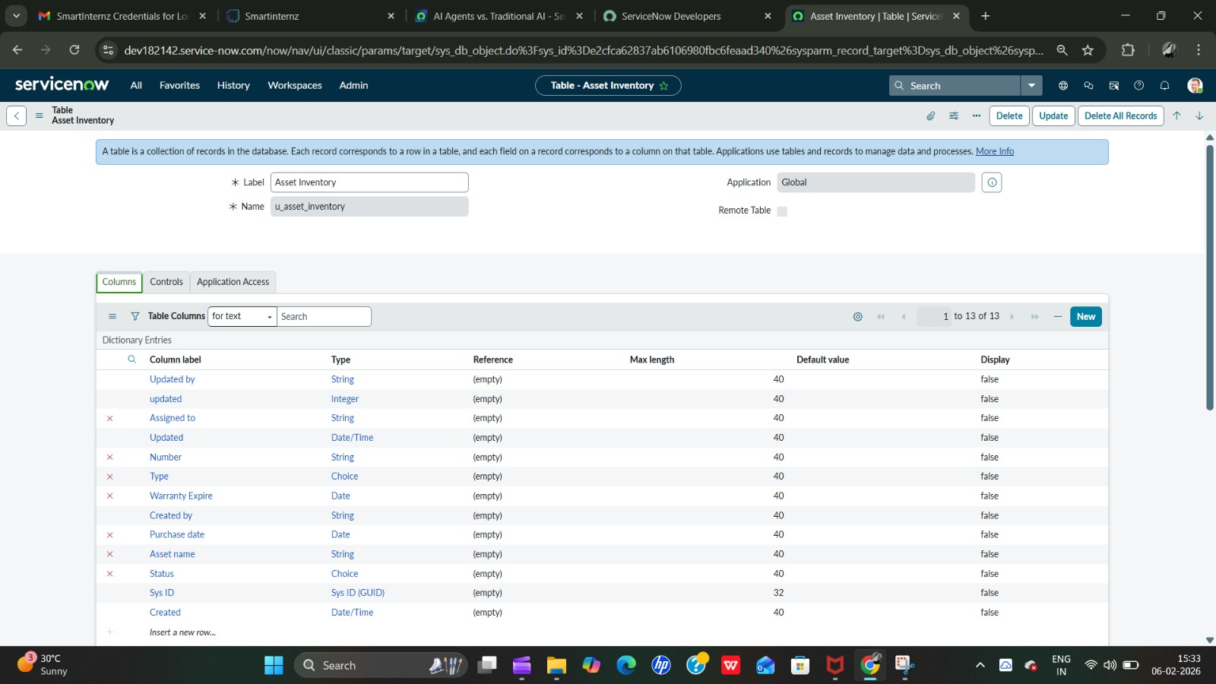

5.2 UI Actions
Description of Mark as Lost, Damaged, and Repaired buttons.
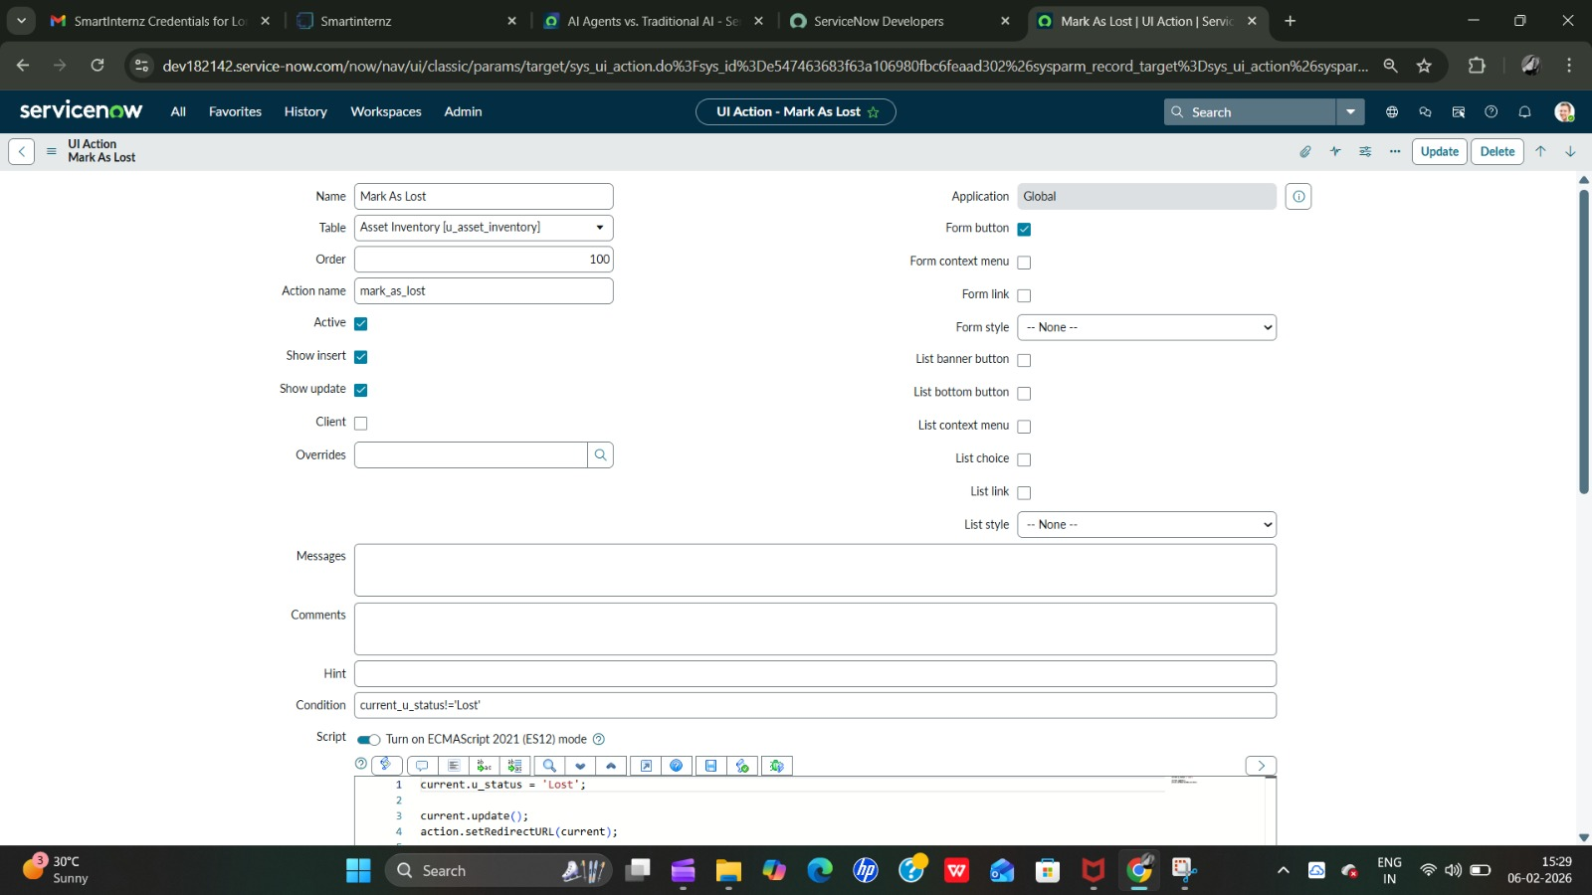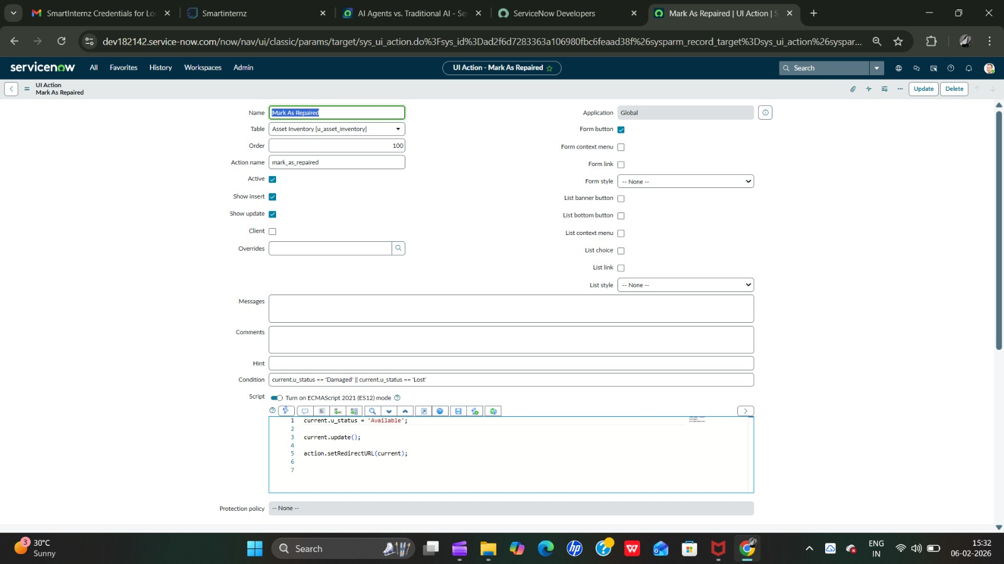
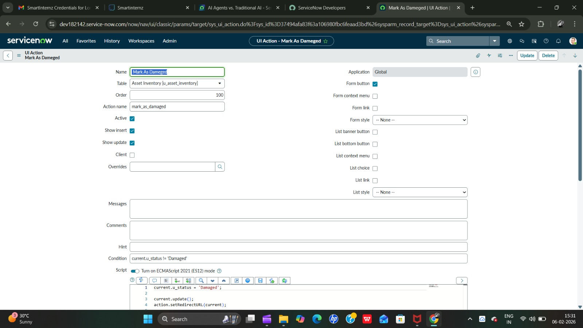

5.3 Scheduled Script - Warranty Expiry
Description of automated background script for warranty expiry alerts.
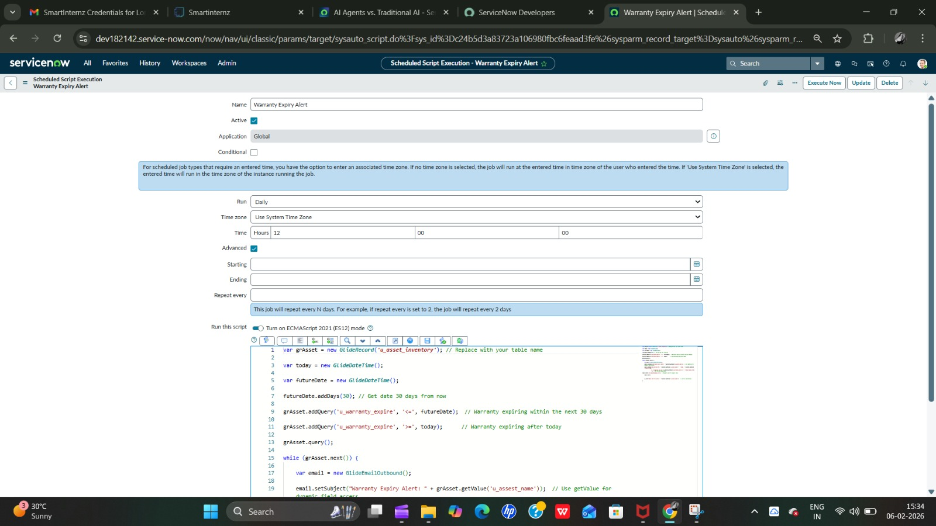

5.4 Reports
Report showing Available vs Assigned Assets.

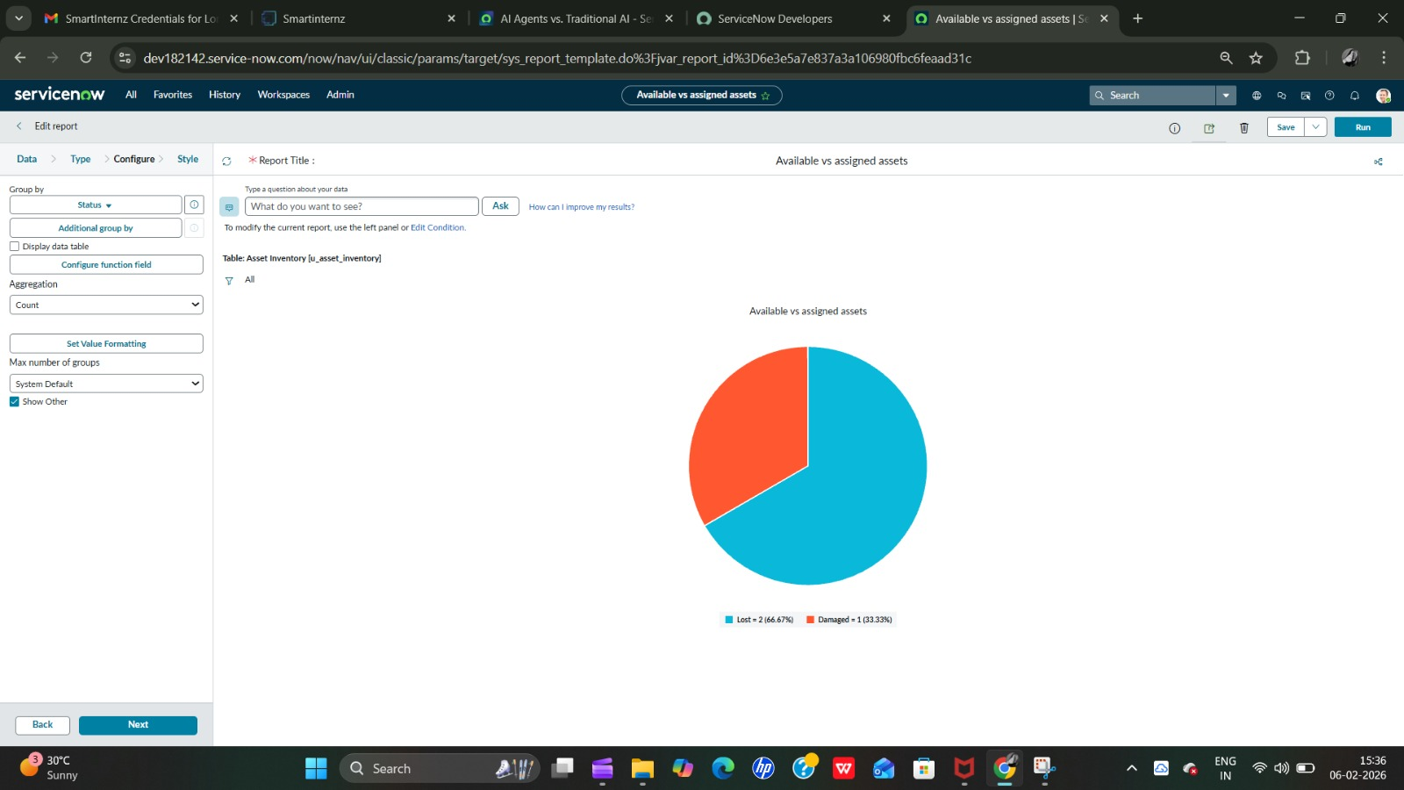

6. Results
The system successfully tracks asset allocation, automates warranty monitoring, and improves transparency in asset management. 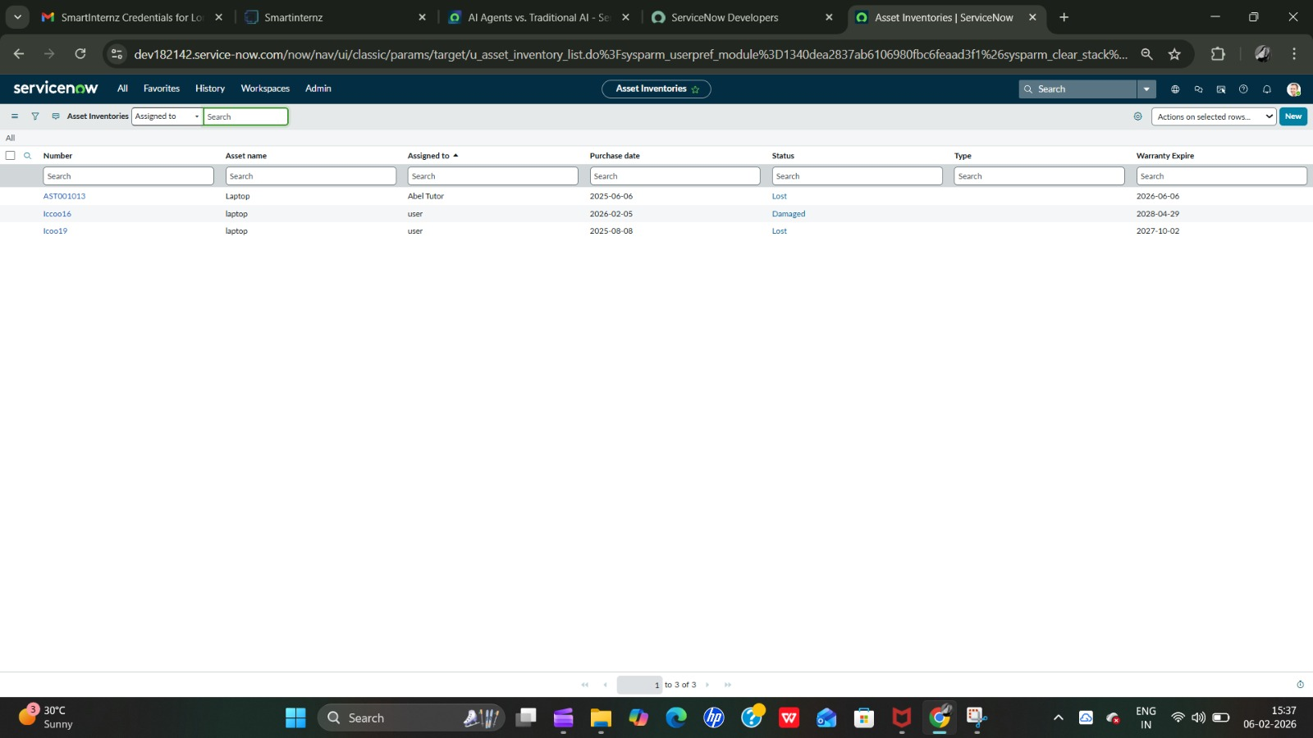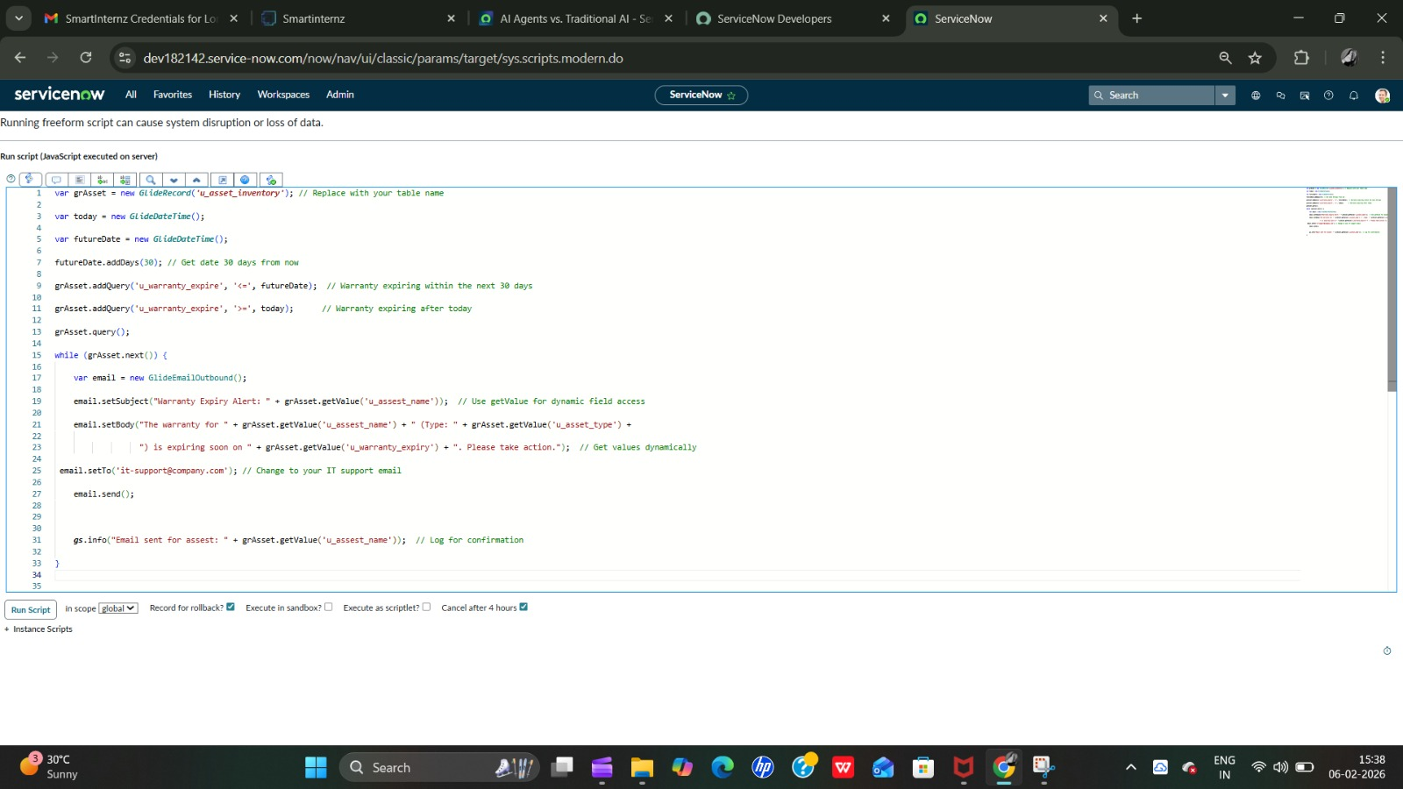 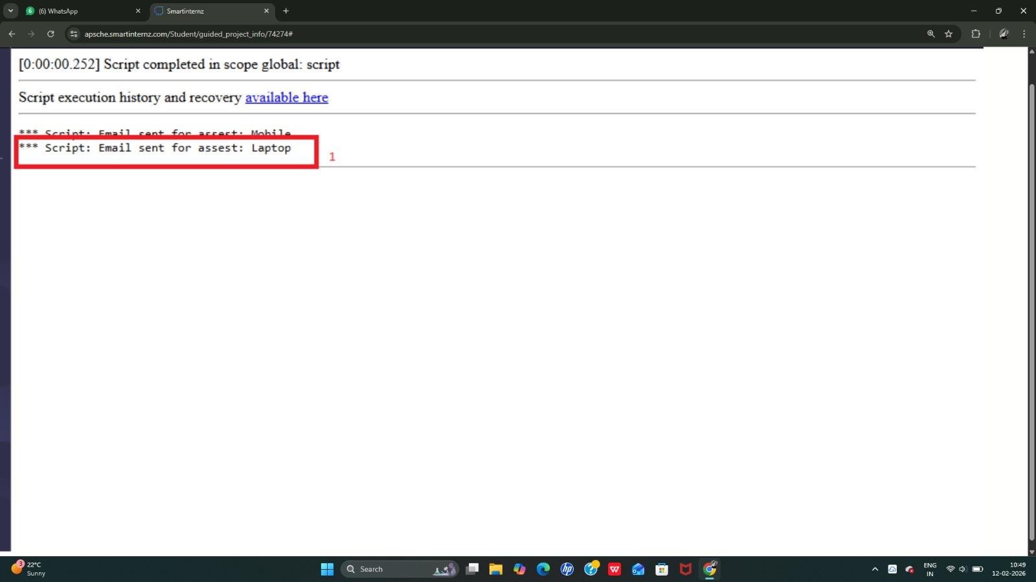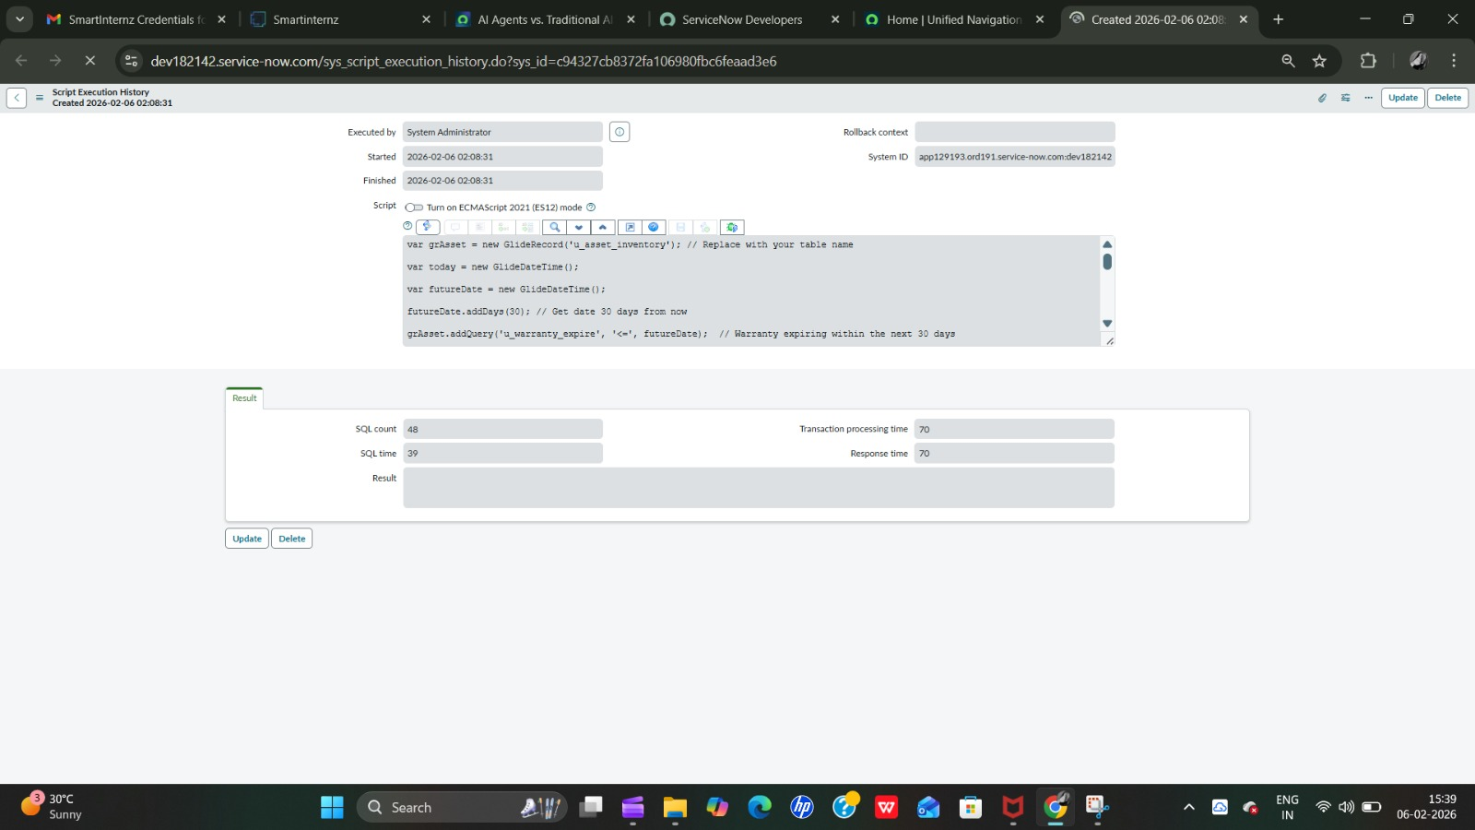

7. Conclusion
The Asset Management Portal enhances operational efficiency by automating asset tracking and management processes. The project demonstrates practical implementation of ServiceNow features including tables, UI actions, scripts, and reporting module.

Submitted By : LTVIP2026TMIDS47831

